Collections framework
The Collection in Java is a framework that provides an architecture to store and manipulate the group of objects.
Java Collections can achieve all the operations that you perform on a data such as searching, sorting, insertion, manipulation, and deletion.
Java Collection means a single unit of objects
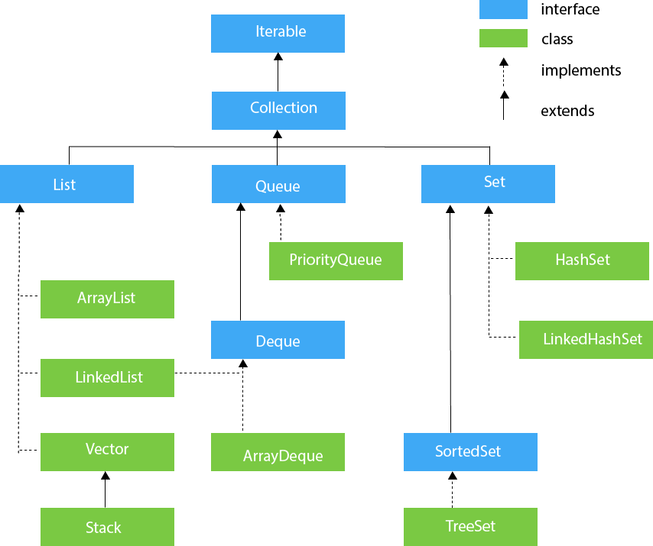

ArrayList: The ArrayList class implements the List interface. It uses a dynamic array to store the duplicate element of different data types.
import java.util.*;
class TestJavaCollection1{
public static void main(String args[]){
ArrayList<String> list=new ArrayList<String>();//Creating arraylist
list.add("Ravi");//Adding object in arraylist
list.add("Vijay");
list.add("Ravi");
list.add("Ajay");
//Traversing list through Iterator
Iterator itr=list.iterator();
while(itr.hasNext()){
System.out.println(itr.next());
}
}
}
creating ArrayList : to create an ArrayList use the Array list class.
syntax: ArrayList<String> list=new ArrayList<String>();
here the arraylist is list(variable , instance of ArrayList class).
<String> datatype of the objects to be stored in list.
adding objects :
- .add(objects)

